Ecocatch Intensive Program
Norr Malma Field Station / Erken laboratory
Photo Report

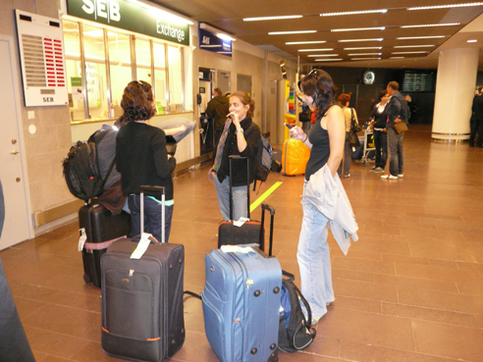
Fig. Arrival of Students and teachers at Arlanda Airport, Sweden.
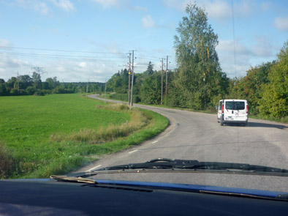
Fig. Transportation to Norr Malma Field Station, Sweden.
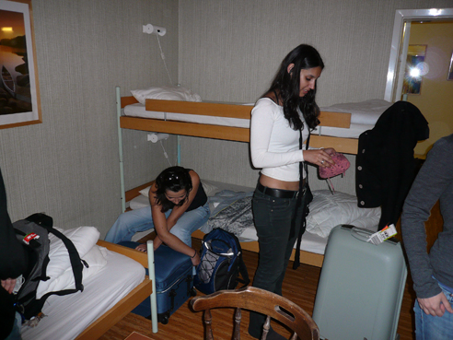
Fig. Getting organized at the field station: the installations.
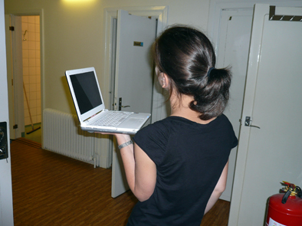
Fig. Searching for a wireless network at the field station.
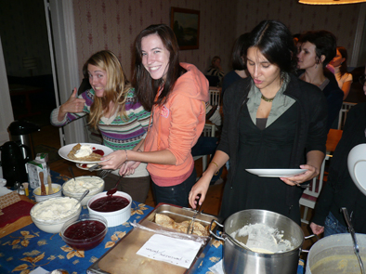
Fig. The first dinner
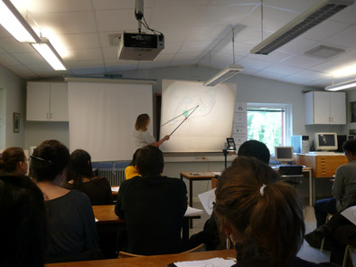
Fig. Opening lecture
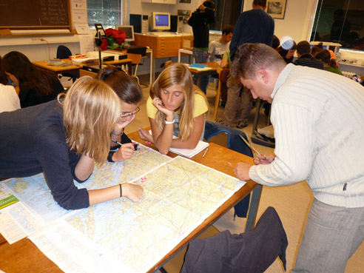
Fig. The first practical assignment: calculating the catchment boundaries from maps
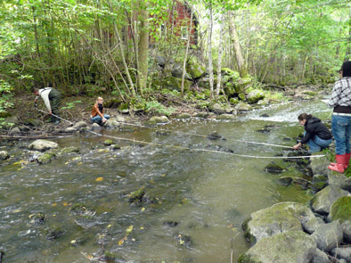
Fig. Fieldwork in Uppsala: River Habitat Survey in River Hågaån.
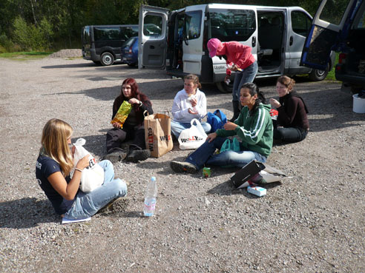
Fig. Lunch break during the fieldwork.
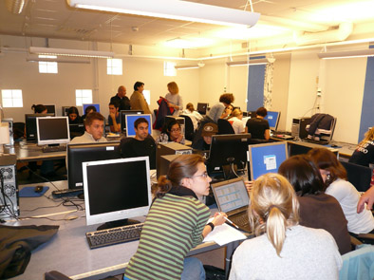
Fig. Computer work at the Evolutionary Biology Center
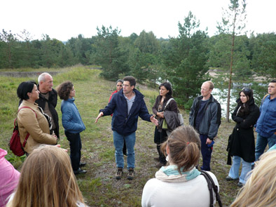
Fig. Field trip to the Uppsala Water Treatment Plant
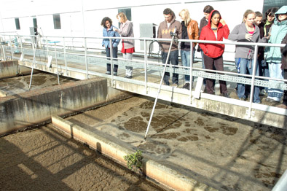
Fig. Field trip to the Uppsala Sewage Treatment Plant
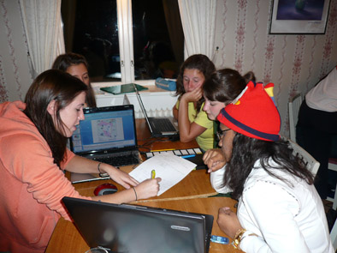
Fig. Group assignment evening work at Norr Malma Field Station
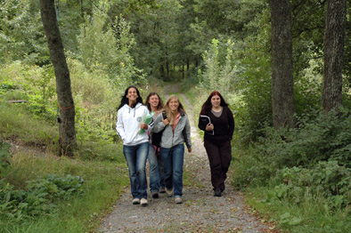
Fig. Students going to classes
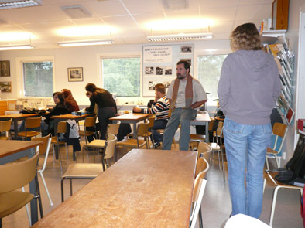
Fig. Waiting for the students at 8:55 AM.
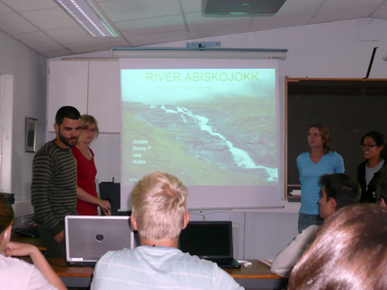
Fig. Students presentation of group assignments
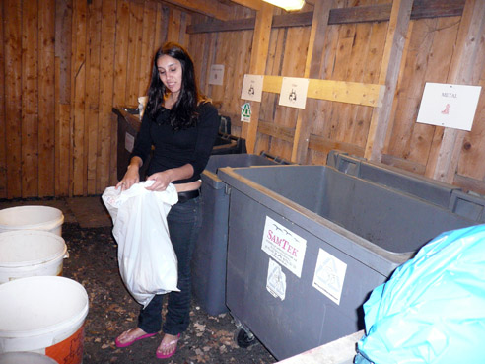
Fig. Cleaning was an every day task
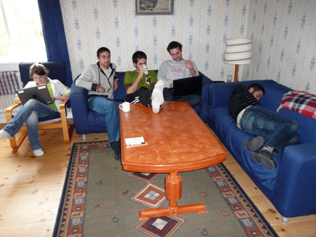
Fig. A much needed break.
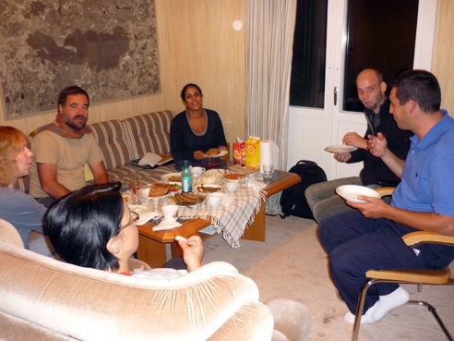
Fig. Evening teachers meeting to prepare the following days work
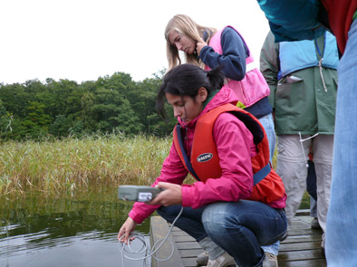
Fig. Field work in Lake Erken: measurement of water quality
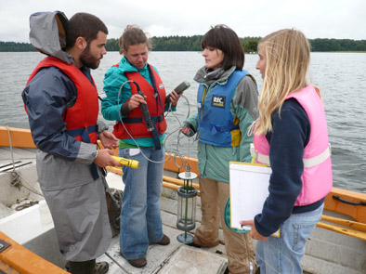
Fig. Field work in Lake Erken: retrieving water samples
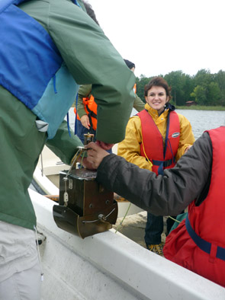
Fig. Field work in Lake Erken: soft sediment sampling
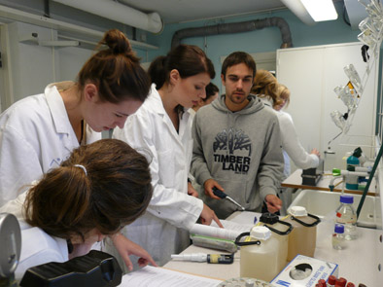
Fig. Laboratory work at Erken Laboratory: chemistry group
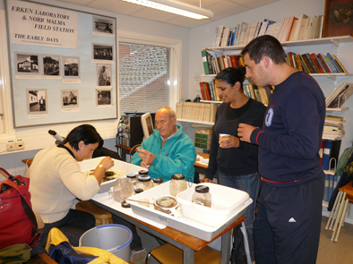
Fig. Laboratory work at Erken lab: macroinvertebrate sorting
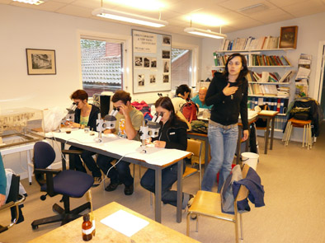
Fig. Laboratory work at Erken lab: macroinvertebrate identification
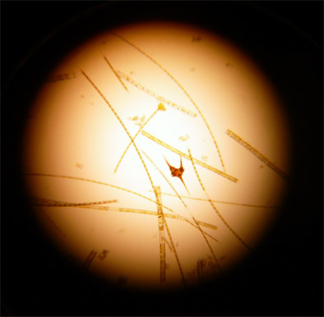
Fig. Field work in Lake Erken: phytoplankton sample
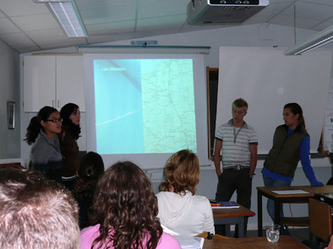
Fig. Students presentation of fieldwork conclusions
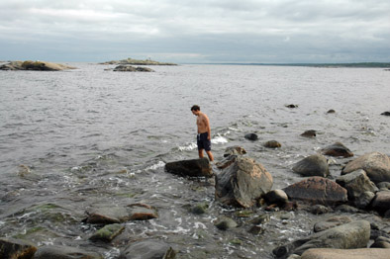
Fig. Who said that the Baltic was cold?
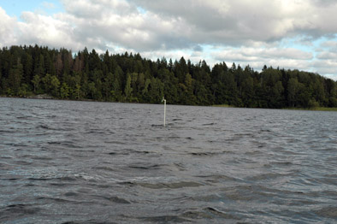
Fig. A tap in the lake?
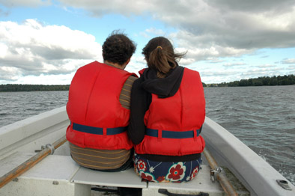
Fig. Students mingling
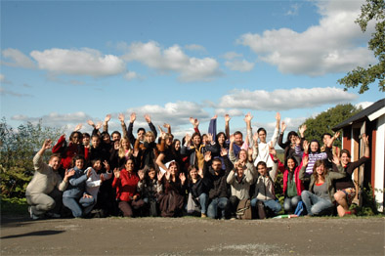
Fig. The farewell
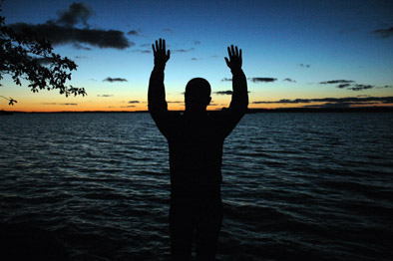
Fig. The final farewell

Compiled by Adriano A. Bordalo
Photo credits: Adriano A. Bordalo, Hanane Perrein-Ettajani, Andre Savva-Bordalo

